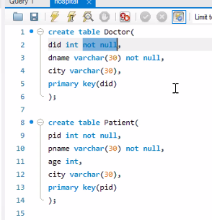

did int not null

告诉你是id， id需要是一个Int，而且不能是Null

primary key就是指定一个元素作为key

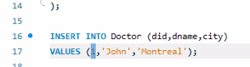

create database Hospital;use Hospital;create table Doctor(did int not null,dname varchar(30) not null,city varchar(30),primary key(did));create table Patient(pid int not null,pname varchar(30) not null,age int,city varchar(30),primary key(pid));INSERT INTO Doctor (did,dname,city)VALUES (1,'John','Montreal');INSERT INTO Doctor (did,dname,city)VALUES (2,'Alex','Torento');INSERT INTO Patient (pid,pname,age,city)VALUES (1,'Mark',23,'Montreal');INSERT INTO Patient (pid,pname,age,city)

VALUES (2,'Emma',32,'Edmonton');